Ex. No:1 | Git Essentials – Commit, Push, Merge, and Pull Requests
07-08-2025

Aim
The aim is to demonstrate pushing changes to a GitHub repository, covering setup, managing visibility, and executing basic Git operations.

Description
The aim of the experiment is to demonstrate the process of pushing changes to a GitHub repository. This involves:
1. Setting up Git: Ensure Git is installed on your computer.
2. Managing Repository Visibility: Understand the effects of making a repository private or public on GitHub.
3. Changing Repository Visibility: Learn how to change the visibility of a repository on GitHub.
4. Pushing Changes to the Repository: Make changes to a local repository, commit them, and push
them to the remote repository on GitHub.

Introduction of GIT

Git is one of the ways of implementing the idea of version control. It is Distributed
Version Control System.

Prerequisites

- GitHub account
- Git Bash

Procedure

STEP 1 — Create a new project folder

# Initialize a new Git repository

git init

# Set username and email (only once per system)

git config --global user.name "Your Name"

git config --global user.email "your.email@example.com"

# Check current configuration

git config --list

STEP 2 — Clone A repository

git clone https://github.com/joyshjj12/devops_exp1.git

STEP 3 — Check Repository Status

git status

STEP 4 — Add and Commit Changes

# Add a single file

git add random_file.txt

# Add all files in the directory

git add .

git commit -m "First commit for new file"

STEP 5 — Initialize Git & push to GitHub

git remote add origin https://github.com/joyshjj12/devops_exp1.git

git push -u origin main

STEP 6 — Pull updates from Remote

git pull origin main

STEP 8 — Branching and Merging

git branch new-feature

git checkout new-feature

git checkout main

git merge new-feature

STEP 9 — Pull Request (via GitHub)

git push origin new-feature

Output

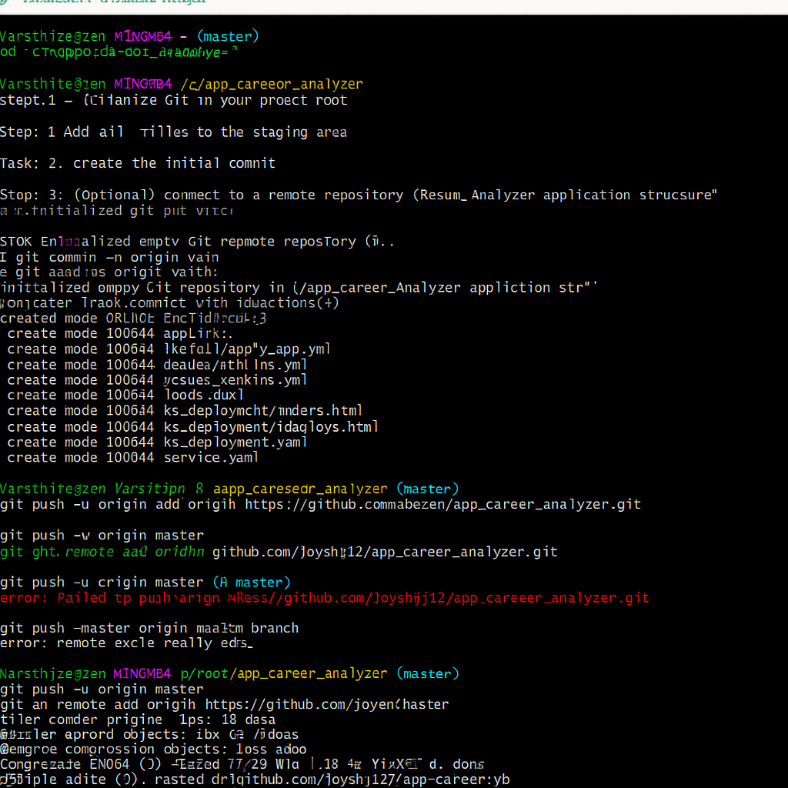

Result
Successfully initialized a Git repository, created and committed changes, pushed updates to the remote repository, merged branches, and submitted a pull request, demonstrating the complete Git workflow from local development to remote collaboration.

